**Advanced Web Development – AJAX Lab**

Points: 10

Due date on blackboard

Aim: The aim of this lab is to understand how to implement AJAX in Rails applications

Instructions:

1. Use the VM supplied in class for this. Please refrain from using your own installs for labs.
2. Please answer all questions – you can be very brief.
3. You may have to refer to the book/slides to understand some things.
4. Develop a RoR application that shows the current time (at the server side) to the user. The index page should have the message “The current time is: <*time>*”. It should also have a button that says “Update”. The user should be able to click the button to update the time. However, only the time portion should get updated – not the entire page.
   1. Code:

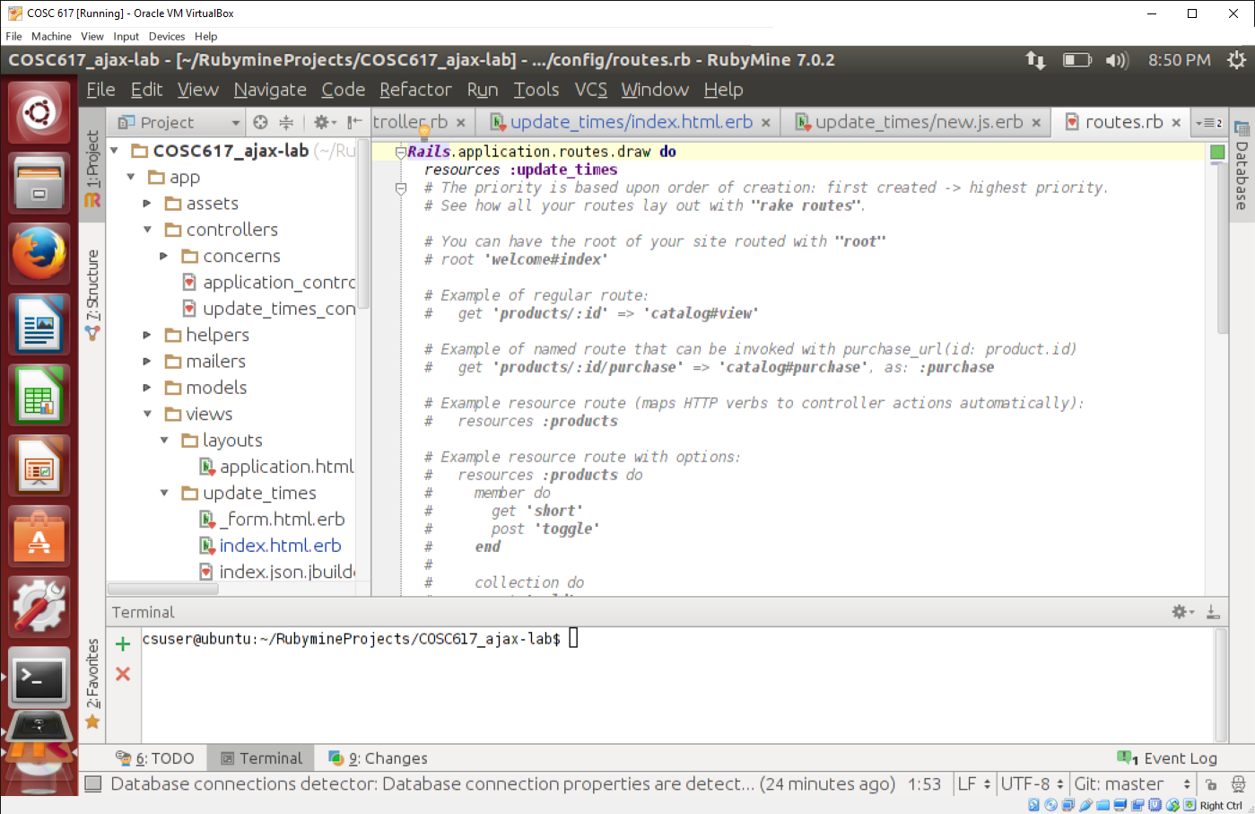

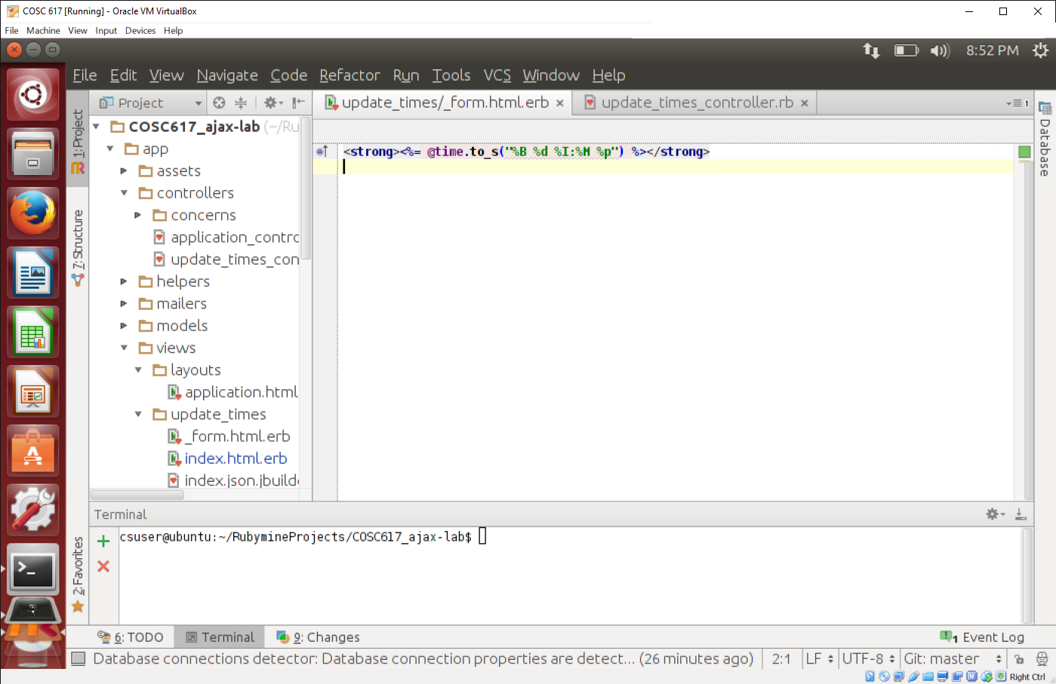

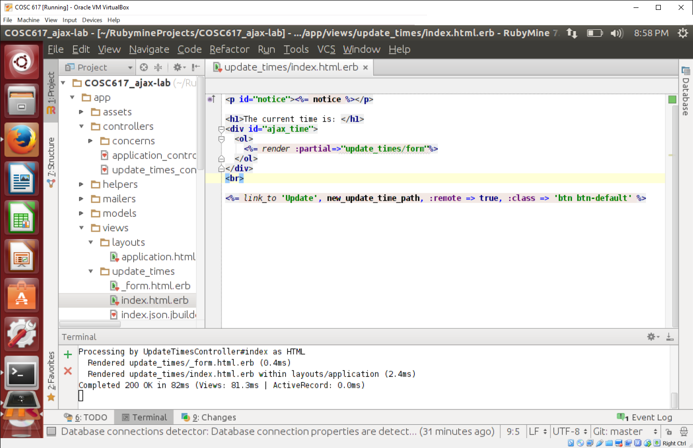

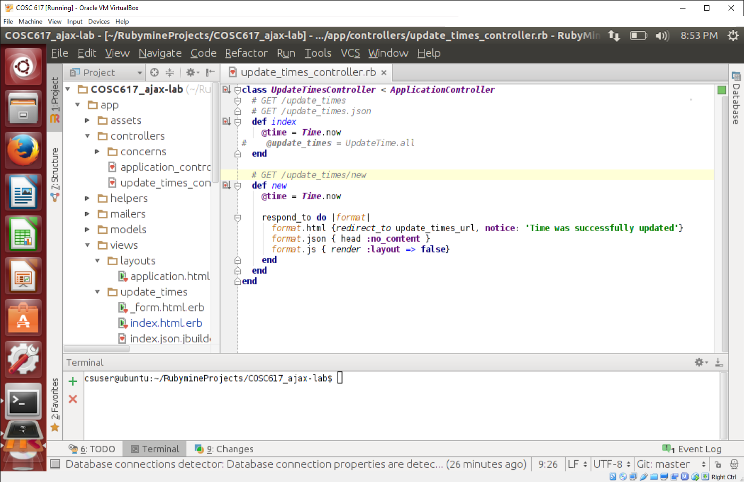

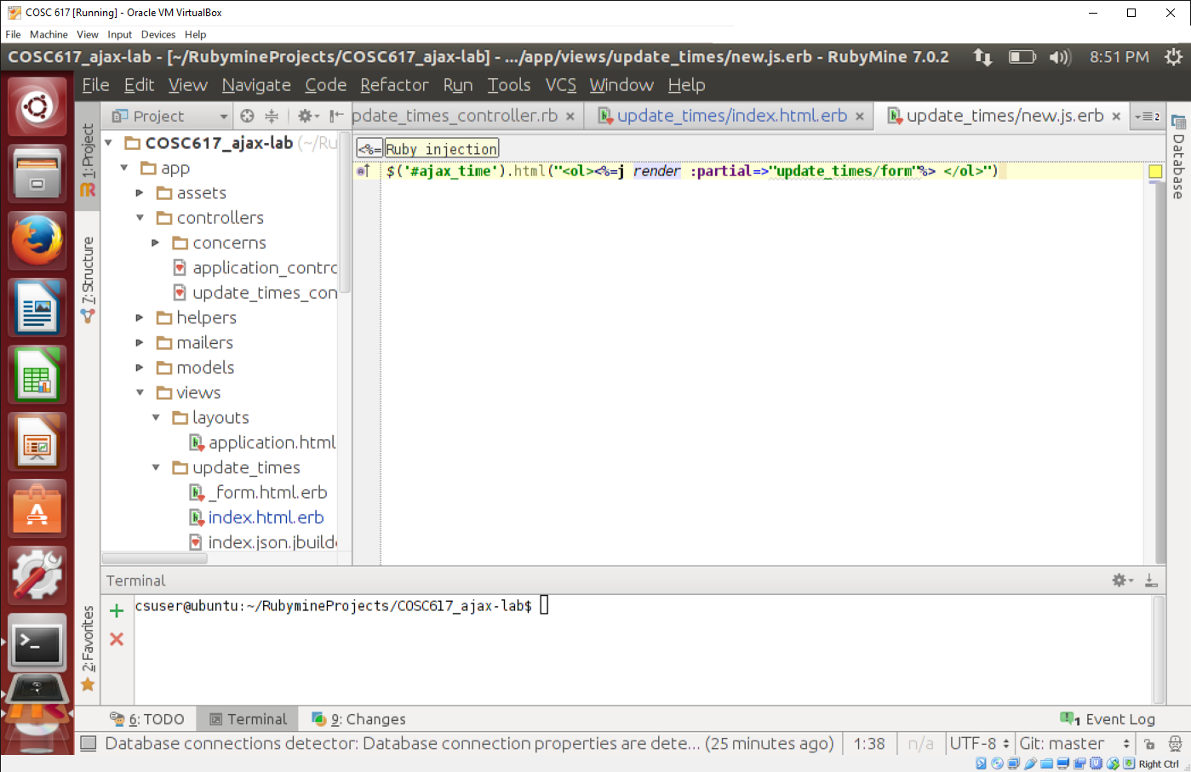

* 1. Application:

